Three into one

Coloured lights can be mixed to make new colours.
Red light and green light add together to make yellow light.

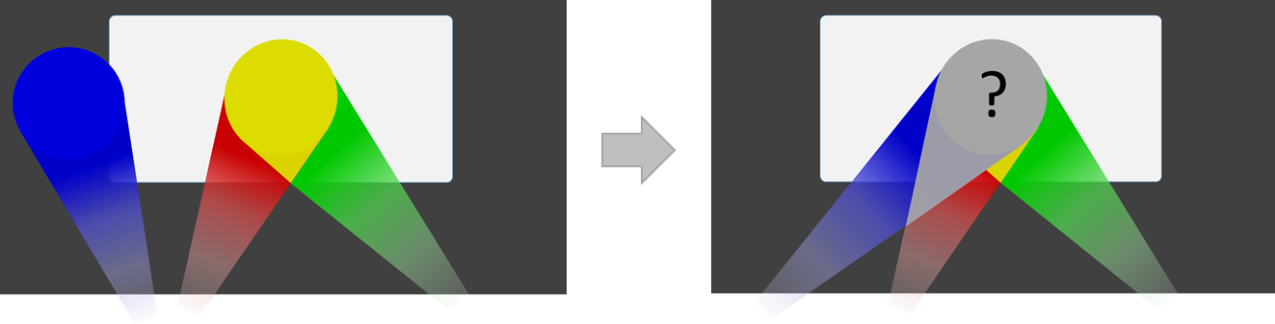

What happens when blue light is added as well?
Which descriptions of the new colour do you think are right?
For each statement, tick (✓) one column to show what you think.
Descriptions of the new colour |  | I am sure this is right | I think this is right | I think this is wrong | I am sure this is wrong
A | It is green
B | It is white
C | It is brighter than the yellow

Physics > Big idea PSL: Sound, light and waves > Topic PSL2: How we see > Key concept PSL2.2: Seeing in colour
Diagnostic question
Three into one

Overview
Learning focus: | Daylight and sunlight are made from all the colours of the spectrum, which together we see as ‘white light’.
Observable learning outcome: | Explain how colours of light combine to make light similar to daylight, which is called white light.
Question type: | Confidence grid
Key words: | White light

What does the research say?
For a physicist, sunlight and daylight are both examples of white light. Each consists of all the colours of the spectrum which combine to be seen as white. Students often regard white light as ‘pure light’ that is free of any tinge. More than half of a sample of 13- to 16-year-olds (n=166) considered colour to be different to light and something that is added to light (Galili and Hazan, 2000).
Haagen-Schutzenhofer (2017) suggests avoiding the term ‘white light’ in the initial stages of instruction and to develop a scientifically sound concept of white light which is related to everyday experiences. She developed a teaching sequence that starts by showing how coloured lights can be mixed to produce another colour of light. Understanding how coloured lights combine to make new (and brighter) colours of light is necessary in order to understand how white light can be made by combining the colours of the spectrum.
This question investigates students’ understanding of how lights of different colours add together, in a way that is different to coloured pigments, to make a brighter light that is closer in colour to white.
Ways to use this question
Students should complete the confidence grid individually. This could be a pencil and paper exercise, or you could use an electronic ‘voting system’ or mini white boards and the PowerPoint presentation.
If there is a range of answers, you may choose to respond through structured class discussion. Ask one student to explain why they gave the answer they did; ask another student to explain why they agree with them; ask another to explain why they disagree, and so on. This sort of discussion gives students the opportunity to explore their thinking and for you to really understand their learning needs.
Differentiation
You may choose to read the questions to the class, so that everyone can focus on the science. In some situations it may be more appropriate for a teaching assistant to read for one or two students.

Expected answers
B and C are correct (and A is wrong).
How to respond - what next?
Students suggesting answer A is correct are adding the blue and yellow light in the same way as they would add coloured pigments when mixing paint.
Our eyes perceive a combination of red, green and blue as white. The screen looks the same in this light as it does in daylight, and because it looks white, we say daylight (and sunlight) is ‘white light’.
The light is brighter than the yellow because extra light has been added.
If students have misunderstandings about how white light is made by adding these three colours, it can help to demonstrate this with three ray lamps using red, green and blue filters. Whilst showing the students this demonstration it is also interesting to show how other colours of the spectrum of light can be obtained by combining red, green and blue in varying amounts.
A useful question to ask students is ‘what colours of light make black?’ Black is the absence of all colours and white (made from all the colours in the spectrum) is the opposite of black.
The following BEST ‘response activity’ could be used in follow-up to this diagnostic question:
- Response activity: Newton’s prisms
Acknowledgments
Developed by Peter Fairhurst (UYSEG).
Images: Peter Fairhurst (UYSEG).
References
Galili, I. and Hazan, A. (2000). Learners' knowledge in optics: interpretation, structure and analysis. International Journal of Science Education, 22(1), 57-88.
Haagen-Schutzenhofer, C. (2017). Students' conceptions on white light and implications for teaching and learning about colour. Physics Education, 52.

